Weather Instruments and Storms Traditional Test: ANSWER KEY

- A
- C
- D
- B
- 70
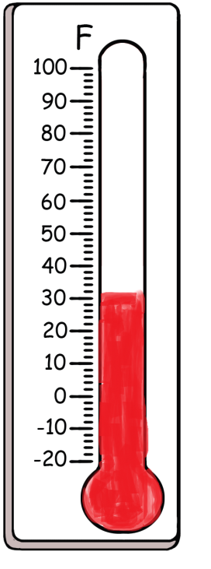
- 30

___B___ 7. A bright flash of electricity that occurs during a thunderstorm
___D____ 8. A very powerful that forms over the ocean with intense wind and heavy rain.
___C____ 9. A cone of air is spinning quickly touching the storm cloud above and the ground.
___A____10. Heavy rain and wind and you hear thunder and see lightning that is produced by cumulonimbus clouds.

A. Thunderstorms

B. Lightning

C. Tornadoes

D. Hurricanes

